Exercise 3: Source Control

WDDM 115 – Tools and Workflow for the Web

Version Control

# Description

Version control (also known as revision control, source control, or source code management) is a class of systems responsible for managing changes to computer programs, documents, large web sites, or other collections of information.

Visual Studio Code has integrated source control management (SCM) and includes Git support out-of-the-box. Git is a free and open source distributed version control system. Many other source control providers are available through extensions on the VS Code Marketplace.

For this exercise, we will start to explore the features of source control integration with Visual Studio Code. This will include installing Git, initializing a repository (a central location in which data is stored and managed), and pushing a commit (transferring files from local to remote) to upload our work to the cloud, allowing us to back up our work and collaborate in teams.

# Tasks

1. Install Git
   1. <https://git-scm.com/>
2. Navigate to the **Source Control** tab in Visual Studio Code

1. Initialize the repository
   1. This will create a local .git folder in the local folder
   2. This .git folder is the folder which does the magic and keeps each and every detail about local branches, remote branches, local check-ins, log history and other information
   3. Once the repository is initialized, the complete folder where the Git has been initialized would start to be tracked
   4. Now git would start tracking this folder and shows the changes made within this folder.
   5. Notice the files have a **U** icon as they are currently untracked in source control.
2. Stage all the files you wish to upload using the **+** button when hovering over each file
   1. This allows you to decide which files to commit, and which to discard

1. Add a helpful message to the commit for future reference
   1. Commit messages are very important because if you ever need to go back to your previous work, you can see exactly what you did in each commit based on the message
2. Graphical user interface, application

   Description automatically generatedCommit & Push the files to upload them to the Git server

1. At this point, you may need to add a remote using GitHub
   1. You will need to create a free GitHub account if you don’t have one already

1. Authorize GitHub for VS Code

1. Allow the extension to open the URI

1. In the GitHub dashboard, create a new repository

1. Select ‘Remote > Add Remote…’

1. Select Add remote from GitHub

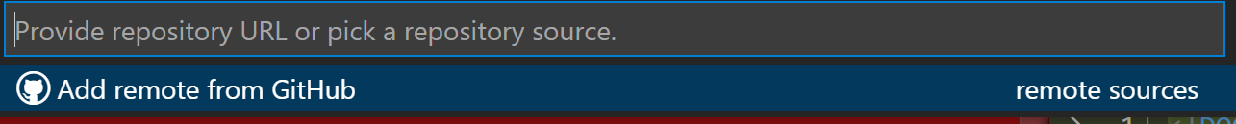

1. Select the repository you just created in GitHub

1. Provide a name for the remote

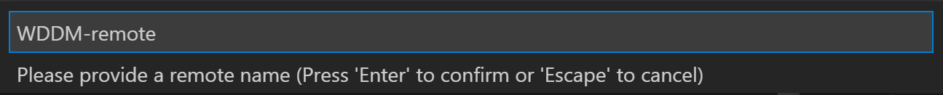

1. Select the ‘…’ button to enable **Source Control Repositories**

1. Click on the master branch
   1. The master branch is no different than any other branch in a cloned Git repository, except that historically it's been the default name used when the first branch is created

1. Create a new branch

1. Publish the branch

1. In the GitHub dashboard, view the new branch you just created and capture a screenshot of it

# Deliverables

Upload the following files to the **Exercise 3** Submission in BlackBoard:

* Screenshot of your new branch in GitHub

# Assessment

This is Exercise 3 out of 5.

This Exercise is worth 10% of the total grade in the course.

Complete the Tasks to score points!

Score Calculation:

0 / 10 – No submission

2.5 / 10 – Missing submission files, minimal effort

5 / 10 – Incomplete tasks

7.5 / 10 – Complete tasks, some errors

8 / 10 – Complete tasks, no errors

9 / 10 - Exceeds the expectations

10 / 10 – Exceeds the expectations significantly